Assignment 6.1: HIVE.

**Problem Statement:**

Create a database named 'custom'.

Create a table named temperature_data inside custom having below fields:

1. date (mm-dd-yyyy) format

2. zip code

3. temperature

The table will be loaded from comma-delimited file.

Load the dataset.txt (which is ',' delimited) in the table.

**OUTPUT:**

Start mysql service, then start hive.

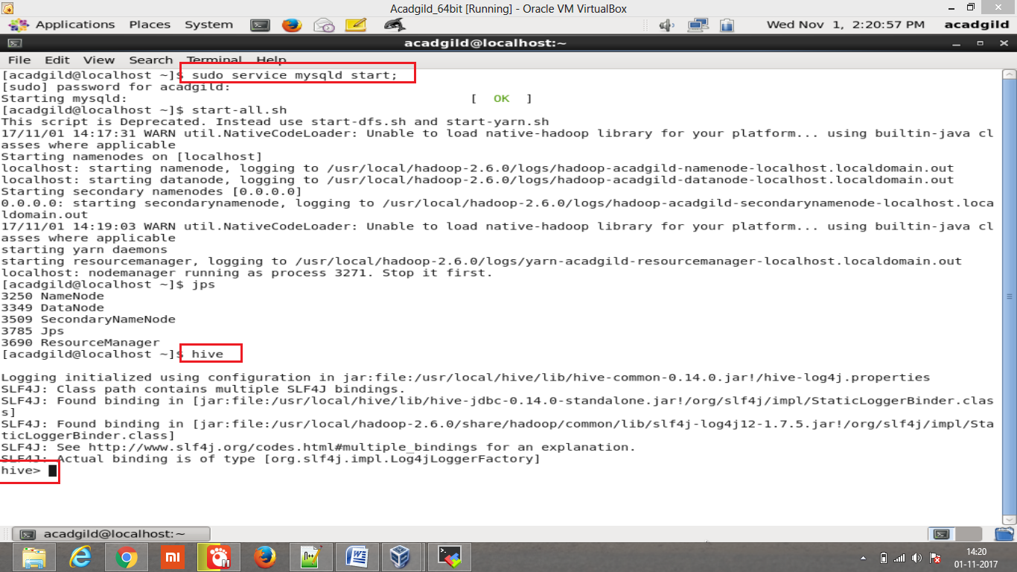

Create data base ‘custome’:

Create database custom;

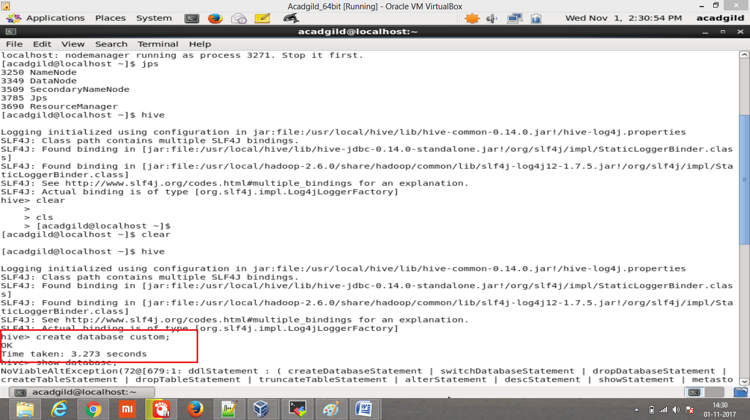

Show databases; -- to show the databases created.

Use custom; --to use the created database.

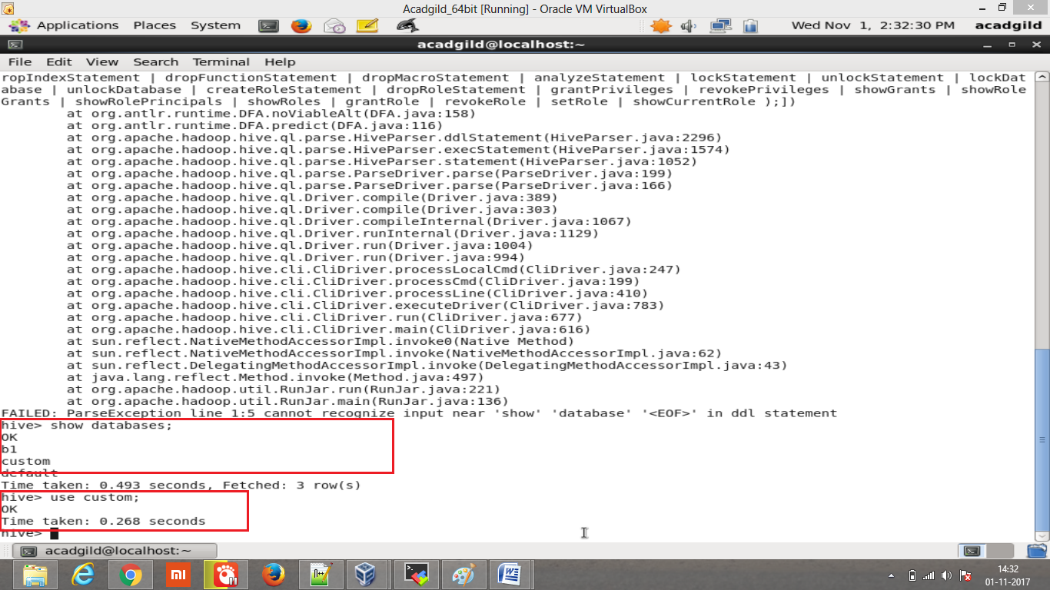

Create the table temperature_data;

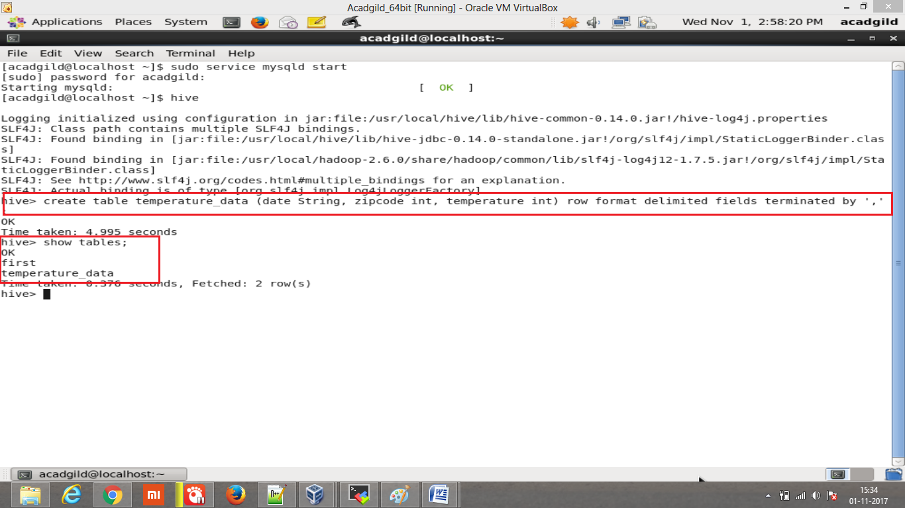

Load the data from local path using LOAD query.

Note: screenshot taken in mobaxterm (as taking the screenshot from VM is not proper)

